UNITED STATES
SECURITIES AND EXCHANGE COMMISSION
Washington, D.C. 20549

SCHEDULE 14A
(Rule 14a-101)
Proxy Statement Pursuant to Section 14(a) of the
Securities Exchange Act of 1934
(Amendment No. )

Filed by the Registrant ☒
Filed by a Party other than the Registrant ☐
Check the appropriate box:

☐ | Preliminary Proxy Statement

☐ | Confidential, for Use of the Commission Only (as permitted by Rule 14a-6(e)(2))

☐ | Definitive Proxy Statement

☐ | Definitive Additional Materials

☒ | Soliciting Material under § 240.14a-12
BOWMAN CONSULTING GROUP LTD.
(Name of Registrant as Specified in its Charter)
(Name of Person(s) Filing Proxy Statement, if Other Than the Registrant)
Payment of Filing Fee (Check all boxes that apply):

☒ | No fee required.

☐ | Fee paid previously with preliminary materials.

☐ | Fee computed on table in exhibit required by Item 25(b) per Exchange Act Rules 14a-6(i)(1) and 0-11.

The following FAQ was sent to employees of Bowman Consulting Group Ltd. on September 14, 2026:

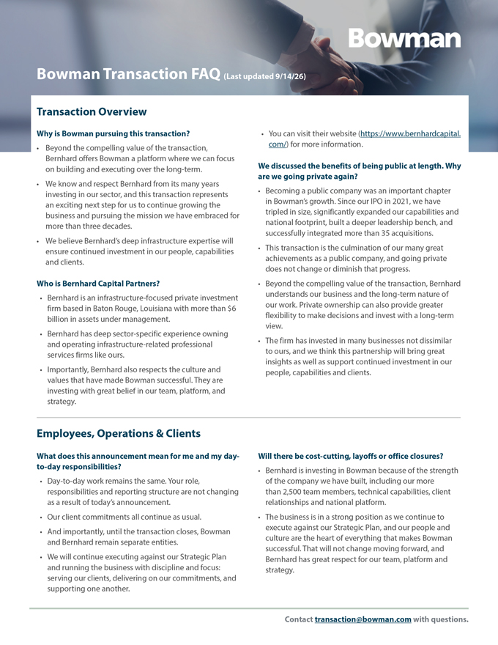
Bowman Transaction FAQ (Last updated 9/14/26) Employees, Operations & Clients (continued)  If there are any future business decisions that affect  Bowman’s identity, reputation and culture are important employees, these decisions will be communicated clearly parts of what Bernhard is investing in. and directly. To reiterate, until the transaction closes, Bowman and Bernhard will continue to operate as Does this change our relationships with clients, business separate entities, and it is business as usual. partners or subcontractors?  No. Client points of contact, project teams, scopes, pricing Will there be changes to Bowman’s offices, name or and commitments continue without change. brand following the transaction?  Our commitments to our clients and to our standards  There are no changes to Bowman’s offices, name or remain as strong as ever. brand to announce at this time.  Our more than 100 U.S. offices and the teams within them are central to the national platform we have built and our ability to serve clients. Compensation, Benefits & Equity How does this impact my compensation and benefits? Can I sell Bowman stock I already own between now and  There are no changes to compensation, payroll or closing? benefits as a result of today’s announcement.  Bowman common stock will continue trading on Nasdaq until the transaction closes.  The merger agreement provides that base salaries and target annual bonus opportunities, excluding equity, will  Employees who hold Bowman shares, including shares be no less than current base salaries and target annual received from vested equity awards, may sell those shares bonus opportunities. only during an applicable open trading window.  Employees must continue to comply with Bowman’s What happens to our benefits plan? insider trading policy, applicable trading windows, and all  There are no changes to current benefits as a result of other legal requirements. today’s announcement.  The company’s existing insider trading policies and  Bowman is currently finalizing the 2027 benefits plan restrictions remain in effect including open and closed in the ordinary course, and this plan will be in place for window periods. the full 2027 year. We expect to communicate additional  We will provide additional guidance regarding the information by the end of September. applicable trading window during the go-shop period.  Open Enrollment remains scheduled for October 26 through November 6. What happens to our 401(k)?  Under the merger agreement, employee benefits will  Under the merger agreement, no changes to the 401(k) generally remain substantially comparable to the benefits plan are expected outside the ordinary course. offered by the company prior to the transaction closing.  Bowman will continue matching employee contributions in accordance with the Company’s existing 401(k) policy. Contact transaction@bowman.com with questions.

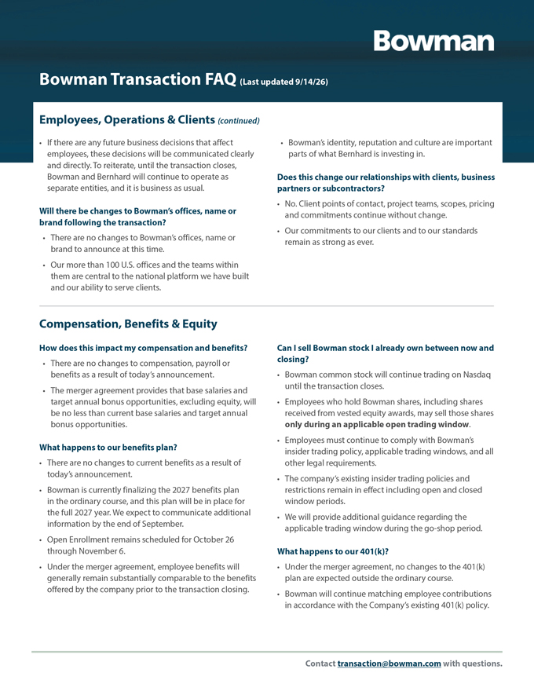
Bowman Transaction FAQ (Last updated 9/14/26) Compensation, Benefits & Equity (continued) How does this affect my participation in the ESPP?  We recognize that our teams will have additional  Employees currently participating in the ESPP for the questions, and we encourage you to submit them to the third quarter will continue through the end of the current dedicated inbox we have set up at transaction@bowman. offering period. com.  That said, no new participants may enroll, and current  We won’t be providing individual responses, nor will we participants may not increase payroll deductions or be able to answer every question in these early stages, elections. but we will review all of the submitted questions and use  There will not be a new offering for the fourth quarter of them as the basis for making regular updates to this FAQ. 2026. The ESPP will terminate subject to the transaction What happens to equity awards that have not yet closing. vested?  Shares purchased through the final offering period will  Outstanding equity awards granted on or before July 4, be treated like other Bowman shares at closing, and 2026 will have their vesting accelerated at closing and any remaining cash contributions will be returned to will be converted into cash based on the $43.00-per-share participants. transaction price.  Additional information regarding the final purchase  Awards granted after July 4, 2026 will be converted into period and any required employee actions will be cash based on the $43.00-per-share transaction price and communicated directly. paid annually over three years, subject to the applicable What happens to the Bowman stock and equity awards service requirements, vesting schedules and other terms I own? of the grant agreement.  This is an all-cash transaction. Upon closing, each share of  Additional information will be provided directly to Bowman common stock will be converted into the right employees who hold equity awards. to receive $43.00 in cash.  The treatment of restricted stock and other employee equity will be managed in accordance with the merger agreement and the respective Equity Grant Agreement, which we will clearly explain for our teams as those items become relevant. Leadership Who will lead Bowman after Gary’s planned retirement?  In light of the transaction, the search for Bowman’s next What happens to the CEO search? CEO will be a collaborative process involving several  As previously announced, Gary will continue serving as parties, including our new partners. CEO through the end of 2026.  Decisions and updates about post-closing leadership will  Further, our CFO Bruce Labovitz, COO Dan Swayze, and become clear as this process unfolds, and those will be the broader leadership team also remain in place to communicated promptly and with transparency. ensure continuity through the duration of this process. Contact transaction@bowman.com with questions.

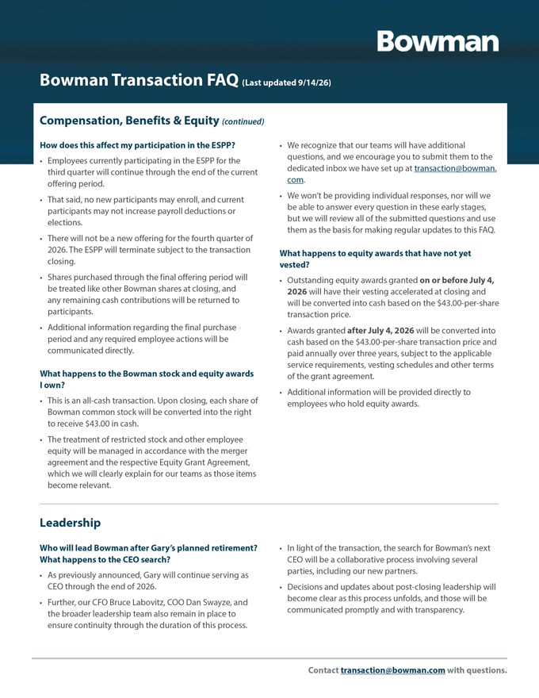
Bowman Transaction FAQ (Last updated 9/14/26) Transaction Timeline & Process What happened during the “go-shop” period?  The Bernhard team is also looking forward to introducing  Under the “go-shop” provision, our Board of Directors themselves to our teams and sharing more about how and its advisors were permitted to solicit and evaluate they will partner with our management team to support the full landscape of opportunities for Bowman and our the company’s next chapter for growth. shareholders.  We will continue to share additional information as we  During that period, which has now concluded, Bowman move through the process. and its advisors engaged with a number of potentially interested parties. What are the next steps?  Ultimately, the Board remains unanimous in its belief  The transaction is expected to close during the fourth that the transaction with Bernhard represents the most quarter of calendar year 2026, subject to approval by compelling path forward for Bowman. Bowman shareholders, receipt of required regulatory approvals and the satisfaction or waiver of other Does this mean the transaction with Bernhard is now customary closing conditions. final?  In the meantime, it is critical that we maintain our  No. The conclusion of the “go-shop” window is an operating rhythm and keep projects, integration work and important step in the process, but the transaction has not growth initiatives on track. yet closed.  We will continue to have an open dialogue as this process  The transaction remains subject to approval by Bowman unfolds. We will also share updates through Company shareholders, receipt of required regulatory approvals communications, Town Halls and managers. and other customary closing conditions.  During this process, our team’s support, flexibility, and  We continue to expect the transaction to close in the continued dedication will be greatly appreciated. fourth quarter of 2026. When do you expect to be able to share more details? Will we learn more about Bernhard’s plans for Bowman?  Certain details are still being finalized, while others are When? confidential or subject to legal restrictions.  Yes. As we move toward closing, we expect to be able to  We will share additional information as decisions share more information about Bernhard and its vision for are made and when we are able to do so. In the this next chapter. meantime, employees should rely on official Company communications and avoid speculation. Communications Guidance What should I do if I am contacted by an outside party?  Please refrain from discussing the transaction on social media and continue to follow Bowman’s existing  Please do not comment on or speculate about the communications policies. transaction. Who should I contact with questions?  For any media, investor and non-project related- external inquiries, please don’t respond and instead direct those to  We encourage you to continue submitting questions as our external communications representatives at Collected you have them to transaction@bowman.com. Strategies (BWMN-CS@collectedstrategies.com).  For any inquiries you may receive from clients or suppliers, please route those to your Divisional Manager or Executive Leader. Contact transaction@bowman.com with questions.

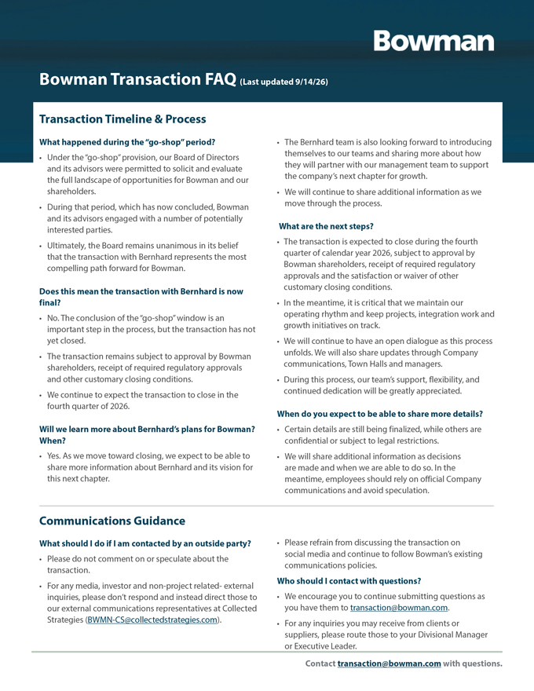
Bowman Transaction FAQ (Last updated 9/14/26) Important Information and Where to Find It The merger transaction described in this communication is contained in the Company’s proxy statement on (the “Merger”) will be submitted to the Company’s Schedule 14A for the Company’s 2026 Annual Meeting of stockholders for their consideration and approval at a Stockholders, which was filed with the SEC on April 28, 2026 special meeting. In connection with the Merger, Bowman (the “2026 Annual Meeting Proxy Statement”), including Consulting Group Ltd. (the “Company”) intends to file under the headings “Executive and Director Compensation,” with the Securities and Exchange Commission (the “SEC”) “Security Ownership of Certain Beneficial Owners and a preliminary proxy statement on Schedule 14A. Once Management” and “Certain Relationships and Related the SEC completes its review of the preliminary proxy Transactions.” To the extent holdings of the Company’s statement, a definitive proxy statement and a form of proxy securities by such directors or executive officers (or the card will be filed with the SEC and mailed or otherwise identity of such directors or executive officers) change from furnished to the Company’s stockholders. BEFORE MAKING the amounts set forth in the 2026 Annual Meeting Proxy ANY VOTING DECISION, THE COMPANY’S STOCKHOLDERS Statement, such information has been or will be reflected ARE URGED TO READ THE PROXY STATEMENT IN ITS on the Initial Statements of Beneficial Ownership on Form ENTIRETY, WHEN IT BECOMES AVAILABLE, AND ANY OTHER 3 or Statements of Change in Ownership on Form 4 filed DOCUMENTS TO BE FILED WITH THE SEC IN CONNECTION with the SEC. Additional information regarding the interests WITH THE MERGER OR INCORPORATED BY REFERENCE IN of the Company’s directors and executive officers in the THE PROXY STATEMENT (INCLUDING ANY AMENDMENTS OR Merger will be included in the proxy statement relating to SUPPLEMENTS TO THESE DOCUMENTS), IF ANY, BECAUSE the Merger when it is filed with the SEC. You may obtain THEY WILL CONTAIN IMPORTANT INFORMATION ABOUT free copies of these documents using the sources indicated THE MERGER AND THE PARTIES TO THE MERGER. This above. communication is not a substitute for the proxy statement or any other document that may be filed by the Company Cautionary Statement Regarding Forward-Looking with the SEC or sent to its stockholders in connection with Statements the Merger. This communication contains “forward-looking statements” The Company’s investors and stockholders may obtain within the meaning of Section 27A of the Securities Act a free copy of the proxy statement (when available) and of 1933, as amended, and Section 21E of the Securities other documents filed by the Company with the SEC Exchange Act of 1934, as amended. All statements at the SEC’s website at www.sec.gov. In addition, the contained in this communication that do not relate to Company’s investors and stockholders may obtain a free matters of historical fact should be considered forward-copy of the documents filed with the SEC by the Company looking statements, including, without limitation, from the Company’s website at investors.bowman.com statements regarding the Merger, including the expected or by directing a request to the Company by e-mail to ir@ timing of the closing of the Merger, the ability of the parties bowman.com, or by telephone to (703) 464-1000. to complete the Merger considering the various closing conditions, the expected impacts and benefits of the Participants in the Solicitation Merger, the plans, strategies and prospects, both business and financial, of the Company, and any assumptions The Company and certain of its directors, executive officers underlying any of the foregoing. and other members of management and employees may, under the rules of the SEC, be deemed to be participants in In some cases, you can identify forward-looking statements the solicitation of proxies from the Company’s stockholders by terminology such as “aim,” “anticipate,” “assume,” “believe,” in connection with the Merger and other matters to be “contemplate,” “continue,” “could,” “due,” “estimate,” “expect,” voted on at the special meeting of the stockholders. “goal,” “intend,” “may,” “objective,” “plan,” “predict,” “potential,” Information regarding the Company’s directors and “positioned,” “seek,” “should,” “target,” “will,” “would” and executive officers, including a description of their direct other similar expressions that are predictions of or indicate or indirect interests, by security holdings or otherwise, future events and future trends, or the negative of these Contact transaction@bowman.com with questions.

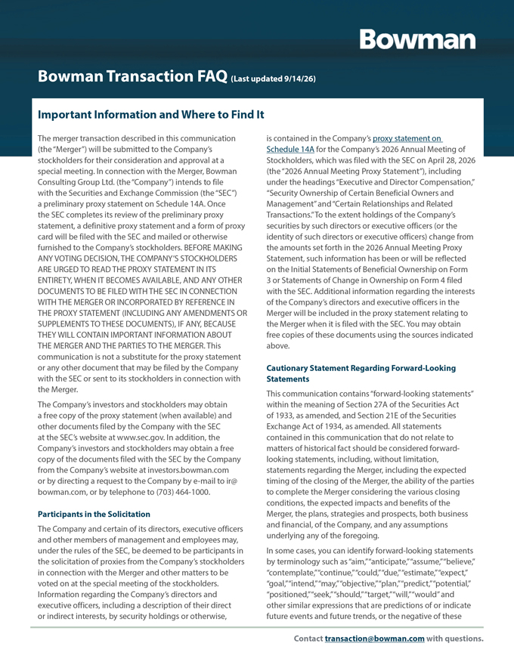
Bowman Transaction FAQ (Last updated 9/14/26) Transaction Timeline & Process What happened during the “go-shop” period?  The Bernhard team is also looking forward to introducing  Under the “go-shop” provision, our Board of Directors themselves to our teams and sharing more about how and its advisors were permitted to solicit and evaluate they will partner with our management team to support the full landscape of opportunities for Bowman and our the company’s next chapter for growth. shareholders.  We will continue to share additional information as we  During that period, which has now concluded, Bowman move through the process. and its advisors engaged with a number of potentially interested parties. What are the next steps?  Ultimately, the Board remains unanimous in its belief  The transaction is expected to close during the fourth that the transaction with Bernhard represents the most quarter of calendar year 2026, subject to approval by compelling path forward for Bowman. Bowman shareholders, receipt of required regulatory approvals and the satisfaction or waiver of other Does this mean the transaction with Bernhard is now customary closing conditions. final?  In the meantime, it is critical that we maintain our  No. The conclusion of the “go-shop” window is an operating rhythm and keep projects, integration work and important step in the process, but the transaction has not growth initiatives on track. yet closed.  We will continue to have an open dialogue as this process  The transaction remains subject to approval by Bowman unfolds. We will also share updates through Company shareholders, receipt of required regulatory approvals communications, Town Halls and managers. and other customary closing conditions.  During this process, our team’s support, flexibility, and  We continue to expect the transaction to close in the continued dedication will be greatly appreciated. fourth quarter of 2026. When do you expect to be able to share more details? Will we learn more about Bernhard’s plans for Bowman?  Certain details are still being finalized, while others are When? confidential or subject to legal restrictions.  Yes. As we move toward closing, we expect to be able to  We will share additional information as decisions share more information about Bernhard and its vision for are made and when we are able to do so. In the this next chapter. meantime, employees should rely on official Company communications and avoid speculation. Communications Guidance What should I do if I am contacted by an outside party?  Please refrain from discussing the transaction on social media and continue to follow Bowman’s existing  Please do not comment on or speculate about the communications policies. transaction. Who should I contact with questions?  For any media, investor and non-project related- external inquiries, please don’t respond and instead direct those to  We encourage you to continue submitting questions as our external communications representatives at Collected you have them to transaction@bowman.com. Strategies (BWMN-CS@collectedstrategies.com).  For any inquiries you may receive from clients or suppliers, please route those to your Divisional Manager or Executive Leader. Contact transaction@bowman.com with questions.

Bowman Transaction FAQ (Last updated 9/14/26) Important Information and Where to Find It terms or other comparable terminology, although not all services, (xii) competitive pressures and trends in the forward-looking statements contain these words. Forward- Company’s industry and its ability to successfully compete looking statements are based on the Company’s current with its competitors, (xiii) the effect on the Company’s expectations and are not guarantees of future performance. stock price if the Merger is not completed, which may These forward-looking statements are subject to known decline significantly following a termination of the Merger and unknown risks and uncertainties that may cause actual Agreement, (xiv) potential business uncertainty during results to differ materially from the Company’s current the pendency of the Merger, including changes to existing expectations. business relationships; (xv) the significant costs, fees and expenses the Company may incur in connection with the These risks and uncertainties include risks and Merger, and (xvi) the effects of unknown liabilities related to developments related to, among other things, (i) the the Merger on the Company. completion of the proposed Merger on the anticipated terms and timing, or at all, including the parties’ ability to For additional information about other factors that could obtain required stockholder approval, regulatory approvals cause actual results to differ materially from those described and satisfy the other conditions to the completion of the in the forward-looking statements, please refer to the Merger, or the failure to satisfy such conditions, (ii) the Company’s periodic reports and other filings with the SEC, effect of the announcement or pendency of the Merger including risks described under the caption “Risk Factors” on the Company’s business, operating results, financial in the Company’s Annual Report on Form 10-K for the performance, ability to retain and hire key personnel, and fiscal year ended December 31, 2025, and the Company’s relationships with customers, suppliers, competitors and Quarterly Report on Form 10-Q for the fiscal quarter ended others, (iii) the effect of the restrictions imposed by the June 30, 2026, each filed with the SEC, and other filings definitive merger agreement (the “Merger Agreement”) with the SEC, which are accessible on the SEC’s website at during the pendency of the Merger, which may (x) disrupt www.sec.gov and the Company’s Investor Relations page the Company’s current plans and business operations, (y) at investors.bowman.com. The forward-looking statements impact the Company’s ability to pursue certain business included in this communication are made only as of the opportunities or strategic transactions or (z) divert date hereof, and the Company disclaims any obligation management’s attention from ongoing business operations, to update the forward-looking statements in the future, (iv) the availability of financing the Merger, which is not a except as required by applicable law. Forward-looking condition to closing of the Merger, (v) the possibility that statements should be considered in light of these risks and competing offers may be made, and the effect of such uncertainties. Investors and others are cautioned not to competing offers on the Merger and the parties’ respective place undue reliance on forward-looking statements. rights under the Merger Agreement, (vi) the occurrence of any event, change or other circumstances that could No Offer or Solicitation give rise to the termination of the Merger Agreement, This communication is for informational purposes only (vii) the fact that the Company may be required to pay and is not intended to, and does not, constitute an offer to a termination fee to Bernhard if the Merger Agreement sell or the solicitation of an offer to buy any securities or a is terminated in certain circumstances, (viii) litigation solicitation of any vote or approval, nor shall there be any being instituted against the Company, Bernhard or other issuance or sale of securities in any jurisdiction in which parties, including their respective directors, managers or such offer, solicitation or sale would be unlawful prior to officers, in connection with the Merger, which may have an registration or qualification under the securities laws of any unfavorable outcome, (ix) the uncertainty of the outcome such jurisdiction. of any such litigation and its effects on the parties to the Merger Agreement, (x) changes in laws, regulations, or policies, (xi) general economic conditions, nationally and globally, and their effect on the market for the Company’s Contact transaction@bowman.com with questions.



