UNITED STATES
SECURITIES AND EXCHANGE COMMISSION
Washington, D.C. 20549

SCHEDULE 14A
(Rule 14a-101)
Proxy Statement Pursuant to Section 14(a) of the
Securities Exchange Act of 1934
(Amendment No. )

Filed by the Registrant ☒
Filed by a Party other than the Registrant ☐
Check the appropriate box:

☐ | Preliminary Proxy Statement

☐ | Confidential, for Use of the Commission Only (as permitted by Rule 14a-6(e)(2))

☐ | Definitive Proxy Statement

☐ | Definitive Additional Materials

☒ | Soliciting Material under § 240.14a-12
BOWMAN CONSULTING GROUP LTD.
(Name of Registrant as Specified in its Charter)
(Name of Person(s) Filing Proxy Statement, if Other Than the Registrant)
Payment of Filing Fee (Check all boxes that apply):

☒ | No fee required.

☐ | Fee paid previously with preliminary materials.

☐ | Fee computed on table in exhibit required by Item 25(b) per Exchange Act Rules 14a-6(i)(1) and 0-11.

The following FAQ was sent to employees of Bowman Consulting Group Ltd. on August 10, 2026:

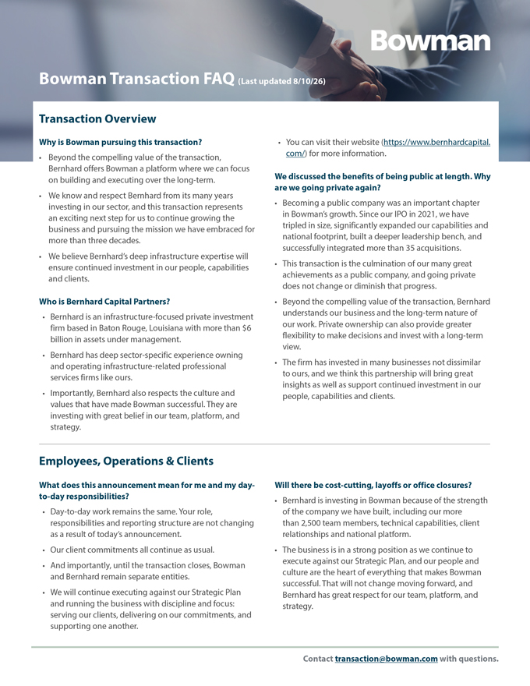
Bowman Transaction FAQ (Last updated 8/10/26) Transaction OverviewEmployees, Operations & ClientsWhy is Bowman pursuing this transaction? Beyond the compelling value of the transaction,Bernhard offers Bowman a platform where we can focuson building and executing over the long-term. We know and respect Bernhard from its many yearsinvesting in our sector, and this transaction representsan exciting next step for us to continue growing thebusiness and pursuing the mission we have embraced formore than three decades. We believe Bernhard’s deep infrastructure expertise willensure continued investment in our people, capabilitiesand clients.Who is Bernhard Capital Partners? Bernhard is an infrastructure-focused private investmentfirm based in Baton Rouge, Louisiana with more than $6billion in assets under management. Bernhard has deep sector-specific experience owningand operating infrastructure-related professionalservices firms like ours. Importantly, Bernhard also respects the culture andvalues that have made Bowman successful. They areinvesting with great belief in our team, platform, andstrategy. You can visit their website (https://www.bernhardcapital.com/) for more information.We discussed the benefits of being public at length. hare we going private again? Becoming a public company was an important chapterin Bowman’s growth. Since our IPO in 2021, we havetripled in size, significantly expanded our capabilities andnational footprint, built a deeper leadership bench, andsuccessfully integrated more than 35 acquisitions. This transaction is the culmination of our many greatachievements as a public company, and going privatedoes not change or diminish that progress. Beyond the compelling value of the transaction, Bernhardunderstands our business and the long-term nature ofour work. Private ownership can also provide greaterflexibility to make decisions and invest with a long-termview. The firm has invested in many businesses not dissimilarto ours, and we think this partnership will bring greatinsights as well as support continued investment in ourpeople, capabilities and clients.What does this announcement mean for me and my dayto-day responsibilities? Day-to-day work remains the same. Your role,responsibilities and reporting structure are not changingas a result of today’s announcement. Our client commitments all continue as usual. And importantly, until the transaction closes, Bowmanand Bernhard remain separate entities. We will continue executing against our Strategic Planand running the business with discipline and focus:serving our clients, delivering on our commitments, andsupporting one another.Will there be cost-cutting, layoffs or office closures? Bernhard is investing in Bowman because of the strengthof the company we have built, including our morethan 2,500 team members, technical capabilities, clientrelationships and national platform. The business is in a strong position as we continue toexecute against our Strategic Plan, and our people andculture are the heart of everything that makes Bowmansuccessful. That will not change moving forward, andBernhard has great respect for our team, platform, andstrategy.Contact transaction@bowman.com with questions.

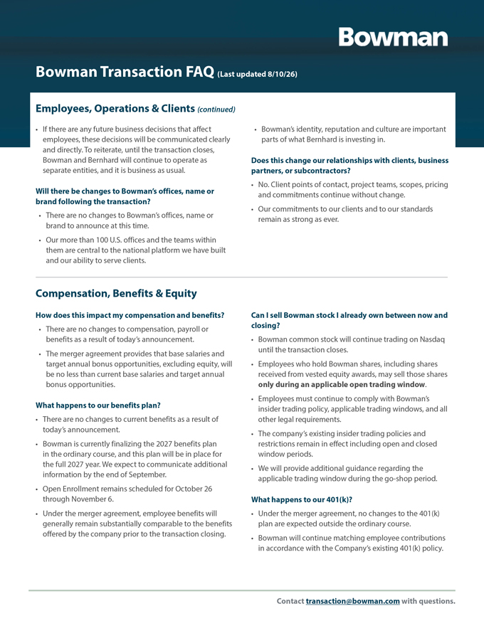
Employees, Operations & Clients (continued) If there are any future business decisions that affect  Bowman’s identity, reputation and culture are important employees, these decisions will be communicated clearly parts of what Bernhard is investing in. and directly. To reiterate, until the transaction closes, Bowman and Bernhard will continue to operate as Does this change our relationships with clients, business separate entities, and it is business as usual. partners, or subcontractors? No. Client points of contact, project teams, scopes, pricing Will there be changes to Bowman’s offices, name or and commitments continue without change. brand following the transaction?  Our commitments to our clients and to our standards  There are no changes to Bowman’s offices, name or remain as strong as ever. brand to announce at this time. Our more than 100 U.S. offices and the teams within them are central to the national platform we have built and our ability to serve clients.Compensation, Benefits & EquityHow does this impact my compensation and benefits? Can I sell Bowman stock I already own between now and  There are no changes to compensation, payroll or closing? benefits as a result of today’s announcement.  Bowman common stock will continue trading on Nasdaq until the transaction closes. The merger agreement provides that base salaries and target annual bonus opportunities, excluding equity, will  Employees who hold Bowman shares, including shares be no less than current base salaries and target annual received from vested equity awards, may sell those shares bonus opportunities. only during an applicable open trading window.  Employees must continue to comply with Bowman’s What happens to our benefits plan? insider trading policy, applicable trading windows, and all  There are no changes to current benefits as a result of other legal requirements. today’s announcement.  The company’s existing insider trading policies and  Bowman is currently finalizing the 2027 benefits plan restrictions remain in effect including open and closed in the ordinary course, and this plan will be in place for window periods. the full 2027 year. We expect to communicate additional  We will provide additional guidance regarding the information by the end of September. applicable trading window during the go-shop period. Open Enrollment remains scheduled for October 26 through November 6. What happens to our 401(k)? Under the merger agreement, employee benefits will  Under the merger agreement, no changes to the 401(k) generally remain substantially comparable to the benefits plan are expected outside the ordinary course. offered by the company prior to the transaction closing. Bowman will continue matching employee contributions in accordance with the Company’s existing 401(k) policy

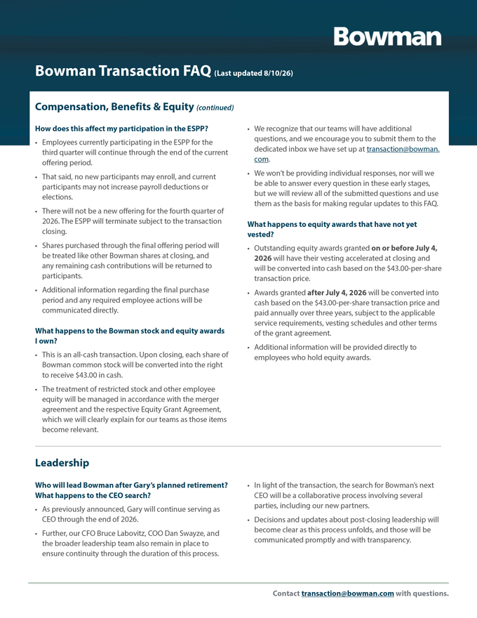
Compensation, Benefits & Equity (continued)How does this affect my participation in the ESPP?  We recognize that our teams will have additional  Employees currently participating in the ESPP for the questions, and we encourage you to submit them to the third quarter will continue through the end of the current dedicated inbox we have set up at transaction@bowman. offering period. com.  That said, no new participants may enroll, and current  We won’t be providing individual responses, nor will we participants may not increase payroll deductions or be able to answer every question in these early stages, elections. but we will review all of the submitted questions and use  There will not be a new offering for the fourth quarter of them as the basis for making regular updates to this FAQ. 2026. The ESPP will terminate subject to the transaction What happens to equity awards that have not yet closing. vested? Shares purchased through the final offering period will  Outstanding equity awards granted on or before July 4, be treated like other Bowman shares at closing, and 2026 will have their vesting accelerated at closing and any remaining cash contributions will be returned to will be converted into cash based on the $43.00-per-share participants. transaction price.  Additional information regarding the final purchase  Awards granted after July 4, 2026 will be converted into period and any required employee actions will be cash based on the $43.00-per-share transaction price and communicated directly. paid annually over three years, subject to the applicable What happens to the Bowman stock and equity awards service requirements, vesting schedules and other terms I own? of the grant agreement.  This is an all-cash transaction. Upon closing, each share of  Additional information will be provided directly to Bowman common stock will be converted into the right employees who hold equity awards. to receive $43.00 in cash. The treatment of restricted stock and other employee equity will be managed in accordance with the merger agreement and the respective Equity Grant Agreement, which we will clearly explain for our teams as those items become relevan.LeadershipWho will lead Bowman after Gary’s planned retirement?  In light of the transaction, the search for Bowman’s next What happens to the CEO search? CEO will be a collaborative process involving several  As previously announced, Gary will continue serving as parties, including our new partners. CEO through the end of 2026.  Decisions and updates about post-closing leadership will  Further, our CFO Bruce Labovitz, COO Dan Swayze, and become clear as this process unfolds, and those will be the broader leadership team also remain in place to communicated promptly and with transparency. ensure continuity through the duration of this process.

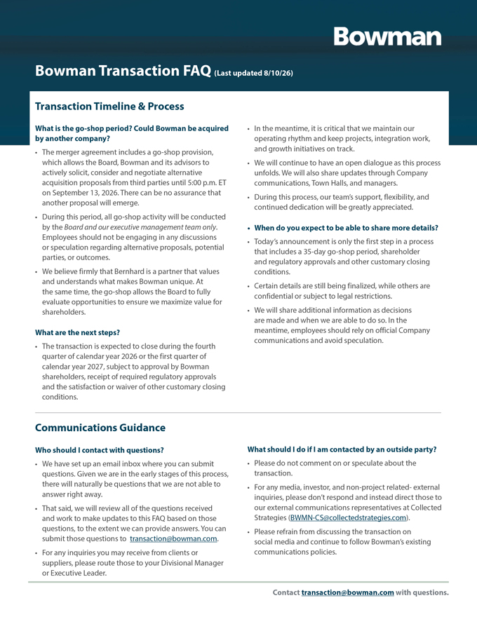
Transaction Timeline & ProcessWhat is the go-shop period? Could Bowman be acquired  In the meantime, it is critical that we maintain our by another company? operating rhythm and keep projects, integration work,  The merger agreement includes a go-shop provision, and growth initiatives on track. which allows the Board, Bowman and its advisors to  We will continue to have an open dialogue as this process actively solicit, consider and negotiate alternative unfolds. We will also share updates through Company acquisition proposals from third parties until 5:00 p.m. ET communications, Town Halls, and managers. on September 13, 2026. There can be no assurance that  During this process, our team’s support, flexibility, and another proposal will emerge. continued dedication will be greatly appreciated. During this period, all go-shop activity will be conducted by the Board and our executive management team only.  When do you expect to be able to share more details?Employees should not be engaging in any discussions  Today’s announcement is only the first step in a process or speculation regarding alternative proposals, potential that includes a 35-day go-shop period, shareholder parties, or outcomes. and regulatory approvals and other customary closing  We believe firmly that Bernhard is a partner that values conditions. and understands what makes Bowman unique. At  Certain details are still being finalized, while others are the same time, the go-shop allows the Board to fully confidential or subject to legal restrictions. evaluate opportunities to ensure we maximize value for shareholders.  We will share additional information as decisions are made and when we are able to do so. In the What are the next steps? meantime, employees should rely on official Company communications and avoid speculation. The transaction is expected to close during the fourth quarter of calendar year 2026 or the first quarter of calendar year 2027, subject to approval by Bowman shareholders, receipt of required regulatory approvals and the satisfaction or waiver of other customary closing conditions.Communications GuidanceWho should I contact with questions? What should I do if I am contacted by an outside party? We have set up an email inbox where you can submit  Please do not comment on or speculate about the questions. Given we are in the early stages of this process, transaction. there will naturally be questions that we are not able to  For any media, investor, and non-project related- external answer right away. inquiries, please don’t respond and instead direct those to  That said, we will review all of the questions received our external communications representatives at Collected and work to make updates to this FAQ based on those Strategies (BWMN-CS@collectedstrategies.com). questions, to the extent we can provide answers. You can  Please refrain from discussing the transaction on submit those questions to transaction@bowman.com. social media and continue to follow Bowman’s existing  For any inquiries you may receive from clients or communications policies. suppliers, please route those to your Divisional Manager or Executive Leader.

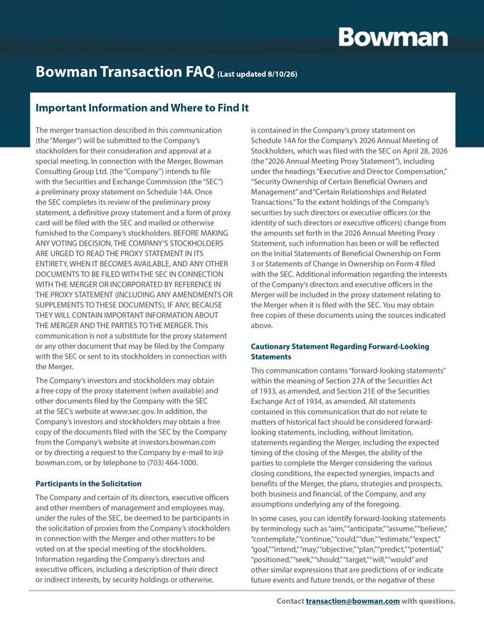
Important Information and Where to Find ItThe merger transaction described in this communication is contained in the Company’s proxy statement on (the “Merger”) will be submitted to the Company’s Schedule 14A for the Company’s 2026 Annual Meeting of stockholders for their consideration and approval at a Stockholders, which was filed with the SEC on April 28, 2026 special meeting. In connection with the Merger, Bowman (the “2026 Annual Meeting Proxy Statement”), including Consulting Group Ltd. (the “Company”) intends to file under the headings “Executive and Director Compensation,” with the Securities and Exchange Commission (the “SEC”) “Security Ownership of Certain Beneficial Owners and a preliminary proxy statement on Schedule 14A. Once Management” and “Certain Relationships and Related the SEC completes its review of the preliminary proxy Transactions.” To the extent holdings of the Company’s statement, a definitive proxy statement and a form of proxy securities by such directors or executive officers (or the card will be filed with the SEC and mailed or otherwise identity of such directors or executive officers) change from furnished to the Company’s stockholders. BEFORE MAKING the amounts set forth in the 2026 Annual Meeting Proxy ANY VOTING DECISION, THE COMPANY’S STOCKHOLDERS Statement, such information has been or will be reflected ARE URGED TO READ THE PROXY STATEMENT IN ITS on the Initial Statements of Beneficial Ownership on Form ENTIRETY, WHEN IT BECOMES AVAILABLE, AND ANY OTHER 3 or Statements of Change in Ownership on Form 4 filed DOCUMENTS TO BE FILED WITH THE SEC IN CONNECTION with the SEC. Additional information regarding the interests WITH THE MERGER OR INCORPORATED BY REFERENCE IN of the Company’s directors and executive officers in the THE PROXY STATEMENT (INCLUDING ANY AMENDMENTS OR Merger will be included in the proxy statement relating to SUPPLEMENTS TO THESE DOCUMENTS), IF ANY, BECAUSE the Merger when it is filed with the SEC. You may obtain THEY WILL CONTAIN IMPORTANT INFORMATION ABOUT free copies of these documents using the sources indicated THE MERGER AND THE PARTIES TO THE MERGER. This above. communication is not a substitute for the proxy statement or any other document that may be filed by the Company Cautionary Statement Regarding Forward-Looking with the SEC or sent to its stockholders in connection with Statements the Merger. This communication contains “forward-looking statements” The Company’s investors and stockholders may obtain within the meaning of Section 27A of the Securities Act a free copy of the proxy statement (when available) and of 1933, as amended, and Section 21E of the Securities other documents filed by the Company with the SEC Exchange Act of 1934, as amended. All statements at the SEC’s website at www.sec.gov. In addition, the contained in this communication that do not relate to Company’s investors and stockholders may obtain a free matters of historical fact should be considered forward-copy of the documents filed with the SEC by the Company looking statements, including, without limitation, from the Company’s website at investors.bowman.com statements regarding the Merger, including the expected or by directing a request to the Company by e-mail to ir@ timing of the closing of the Merger, the ability of the bowman.com, or by telephone to (703) 464-1000. parties to complete the Merger considering the various closing conditions, the expected synergies, impacts and Participants in the Solicitation benefits of the Merger, the plans, strategies and prospects, The Company and certain of its directors, executive officers both business and financial, of the Company, and any and other members of management and employees may, assumptions underlying any of the foregoing. under the rules of the SEC, be deemed to be participants in In some cases, you can identify forward-looking statements the solicitation of proxies from the Company’s stockholders by terminology such as “aim,” “anticipate,” “assume,” “believe,” in connection with the Merger and other matters to be “contemplate,” “continue,” “could,” “due,” “estimate,” “expect,” voted on at the special meeting of the stockholders. “goal,” “intend,” “may,” “objective,” “plan,” “predict,” “potential,” Information regarding the Company’s directors and “positioned,” “seek,” “should,” “target,” “will,” “would” and executive officers, including a description of their direct other similar expressions that are predictions of or indicate or indirect interests, by security holdings or otherwise, future events and future trends, or the negative of these

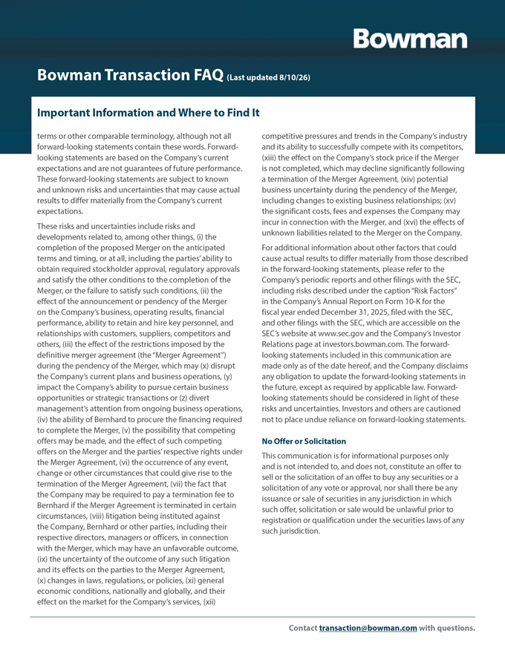
Important Information and Where to Find Itterms or other comparable terminology, although not all competitive pressures and trends in the Company’s industry forward-looking statements contain these words. Forward- and its ability to successfully compete with its competitors, looking statements are based on the Company’s current (xiii) the effect on the Company’s stock price if the Merger expectations and are not guarantees of future performance. is not completed, which may decline significantly following These forward-looking statements are subject to known a termination of the Merger Agreement, (xiv) potential and unknown risks and uncertainties that may cause actual business uncertainty during the pendency of the Merger, results to differ materially from the Company’s current including changes to existing business relationships; (xv) expectations. the significant costs, fees and expenses the Company may incur in connection with the Merger, and (xvi) the effects of These risks and uncertainties include risks and unknown liabilities related to the Merger on the Company. developments related to, among other things, (i) the completion of the proposed Merger on the anticipated For additional information about other factors that could terms and timing, or at all, including the parties’ ability to cause actual results to differ materially from those described obtain required stockholder approval, regulatory approvals in the forward-looking statements, please refer to the and satisfy the other conditions to the completion of the Company’s periodic reports and other filings with the SEC, Merger, or the failure to satisfy such conditions, (ii) the including risks described under the caption “Risk Factors” effect of the announcement or pendency of the Merger in the Company’s Annual Report on Form 10-K for the on the Company’s business, operating results, financial fiscal year ended December 31, 2025, filed with the SEC, performance, ability to retain and hire key personnel, and and other filings with the SEC, which are accessible on the relationships with customers, suppliers, competitors and SEC’s website at www.sec.gov and the Company’s Investor others, (iii) the effect of the restrictions imposed by the Relations page at investors.bowman.com. The forward-definitive merger agreement (the “Merger Agreement”) looking statements included in this communication are during the pendency of the Merger, which may (x) disrupt made only as of the date hereof, and the Company disclaims the Company’s current plans and business operations, (y) any obligation to update the forward-looking statements in impact the Company’s ability to pursue certain business the future, except as required by applicable law. Forward-opportunities or strategic transactions or (z) divert looking statements should be considered in light of these management’s attention from ongoing business operations, risks and uncertainties. Investors and others are cautioned (iv) the ability of Bernhard to procure the financing required not to place undue reliance on forward-looking statements. to complete the Merger, (v) the possibility that competing offers may be made, and the effect of such competing No Offer or Solicitation offers on the Merger and the parties’ respective rights under This communication is for informational purposes only the Merger Agreement, (vi) the occurrence of any event, and is not intended to, and does not, constitute an offer to change or other circumstances that could give rise to the sell or the solicitation of an offer to buy any securities or a termination of the Merger Agreement, (vii) the fact that solicitation of any vote or approval, nor shall there be any the Company may be required to pay a termination fee to issuance or sale of securities in any jurisdiction in which Bernhard if the Merger Agreement is terminated in certain such offer, solicitation or sale would be unlawful prior to circumstances, (viii) litigation being instituted against registration or qualification under the securities laws of any the Company, Bernhard or other parties, including their such jurisdiction. respective directors, managers or officers, in connection with the Merger, which may have an unfavorable outcome, (ix) the uncertainty of the outcome of any such litigation and its effects on the parties to the Merger Agreement, (x) changes in laws, regulations, or policies, (xi) general economic conditions, nationally and globally, and their effect on the market for the Company’s services, (xii)

