UNITED STATES
SECURITIES AND EXCHANGE COMMISSION
Washington, D.C. 20549

SCHEDULE 14A
(Rule 14a-101)
Proxy Statement Pursuant to Section 14(a) of the
Securities Exchange Act of 1934
(Amendment No. )

Filed by the Registrant ☒
Filed by a Party other than the Registrant ☐
Check the appropriate box:

☐ | Preliminary Proxy Statement

☐ | Confidential, for Use of the Commission Only (as permitted by Rule 14a-6(e)(2))

☐ | Definitive Proxy Statement

☐ | Definitive Additional Materials

☒ | Soliciting Material under § 240.14a-12
BOWMAN CONSULTING GROUP LTD.
(Name of Registrant as Specified in its Charter)
(Name of Person(s) Filing Proxy Statement, if Other Than the Registrant)
Payment of Filing Fee (Check all boxes that apply):

☒ | No fee required.

☐ | Fee paid previously with preliminary materials.

☐ | Fee computed on table in exhibit required by Item 25(b) per Exchange Act Rules 14a-6(i)(1) and 0-11.

The following email was sent to employees of Bowman Consulting Group Ltd. on September 14, 2026:

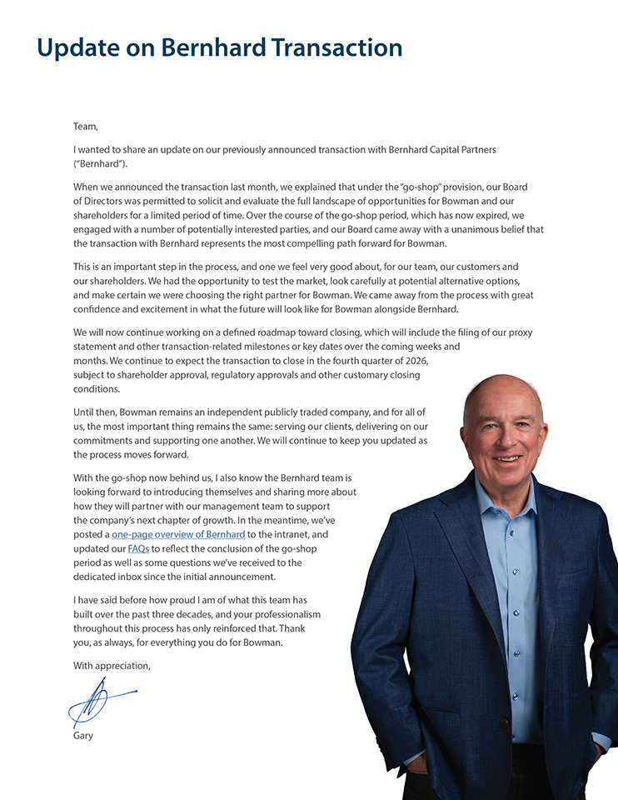
Update on Bernhard Transaction Team, I wanted to share an update on our previously announced transaction with Bernhard Capital Partners (“Bernhard”). When we announced the transaction last month, we explained that under the “go-shop” provision, our Board of Directors was permitted to solicit and evaluate the full landscape of opportunities for Bowman and our shareholders for a limited period of time. Over the course of the go-shop period, which has now expired, we engaged with a number of potentially interested parties, and our Board came away with a unanimous belief that the transaction with Bernhard represents the most compelling path forward for Bowman. This is an important step in the process, and one we feel very good about, for our team, our customers and our shareholders. We had the opportunity to test the market, look carefully at potential alternative options, and make certain we were choosing the right partner for Bowman. We came away from the process with great confidence and excitement in what the future will look like for Bowman alongside Bernhard. We will now continue working on a defined roadmap toward closing, which will include the filing of our proxy statement and other transaction-related milestones or key dates over the coming weeks and months. We continue to expect the transaction to close in the fourth quarter of 2026, subject to shareholder approval, regulatory approvals and other customary closing conditions. Until then, Bowman remains an independent publicly traded company, and for all of us, the most important thing remains the same: serving our clients, delivering on our commitments and supporting one another. We will continue to keep you updated as the process moves forward. With the go-shop now behind us, I also know the Bernhard team is looking forward to introducing themselves and sharing more about how they will partner with our management team to support the company’s next chapter of growth. In the meantime, we’ve posted a one-page overview of Bernhard to the intranet, and updated our FAQs to reflect the conclusion of the go-shop period as well as some questions we’ve received to the dedicated inbox since the initial announcement. I have said before how proud I am of what this team has built over the past three decades, and your professionalism throughout this process has only reinforced that. Thank you, as always, for everything you do for Bowman. With appreciation, Gary

Important Information & Where to Find It

The merger transaction described in this communication (the “Merger”) will be submitted to the Company’s stockholders for their consideration and approval at a special meeting. In connection with the Merger, Bowman Consulting Group Ltd. (the “Company”) intends to file with the Securities and Exchange Commission (the “SEC”) a preliminary proxy statement on Schedule 14A. Once the SEC completes its review of the preliminary proxy statement, a definitive proxy statement and a form of proxy card will be filed with the SEC and mailed or otherwise furnished to the Company’s stockholders. BEFORE MAKING ANY VOTING DECISION, THE COMPANY’S STOCKHOLDERS ARE URGED TO READ THE PROXY STATEMENT IN ITS ENTIRETY, WHEN IT BECOMES AVAILABLE, AND ANY OTHER DOCUMENTS TO BE FILED WITH THE SEC IN CONNECTION WITH THE MERGER OR INCORPORATED BY REFERENCE IN THE PROXY STATEMENT (INCLUDING ANY AMENDMENTS OR SUPPLEMENTS TO THESE DOCUMENTS), IF ANY, BECAUSE THEY WILL CONTAIN IMPORTANT INFORMATION ABOUT THE MERGER AND THE PARTIES TO THE MERGER. This communication is not a substitute for the proxy statement or any other document that may be filed by the Company with the SEC or sent to its stockholders in connection with the Merger.
The Company’s investors and stockholders may obtain a free copy of the proxy statement (when available) and other documents filed by the Company with the SEC at the SEC’s website at www.sec.gov. In addition, the Company’s investors and stockholders may obtain a free copy of the documents filed with the SEC by the Company from the Company’s website at investors.bowman.com or by directing a request to the Company by e-mail to ir@ bowman.com, or by telephone to
(703) 464-1000.
Participants in the Solicitation
The Company and certain of its directors, executive officers and other members of management and employees may, under the rules of the SEC, be deemed to be participants in the solicitation of proxies from the Company’s stockholders in connection with the Merger and other matters to be voted on at the special meeting of the stockholders. Information regarding the Company’s directors and executive officers, including a description of their direct or indirect interests, by security holdings or otherwise, is contained in the Company’s proxy statement on Schedule 14A for the Company’s 2026 Annual Meeting of Stockholders, which was filed with the SEC on April 28, 2026 (the “2026 Annual Meeting Proxy Statement”), including under the headings “Executive and Director Compensation,” “Security Ownership of Certain Beneficial Owners and Management” and “Certain Relationships and Related
Transactions.” To the extent holdings of the Company’s securities by such directors or executive officers (or the identity of such directors or executive officers) change from the amounts set forth in the 2026 Annual Meeting Proxy Statement, such information has been or will be reflected on the Initial Statements of Beneficial Ownership on Form 3 or Statements of Change in Ownership on Form 4 filed with the SEC. Additional information regarding the interests of the Company’s directors and executive officers in the Merger will be included in the proxy statement relating to the Merger when it is filed with the SEC. You may obtain free copies of these documents using the sources indicated above.
Cautionary Statement Regarding Forward-Looking Statements
This communication contains “forward-looking statements” within the meaning of Section 27A of the Securities Act of 1933, as amended, and Section 21E of the Securities Exchange Act of 1934, as amended. All statements contained in this communication that do not relate to matters of historical fact should be considered forward-looking statements, including, without limitation, statements regarding the Merger, including the expected timing of the closing of the Merger, the ability of the parties to complete the Merger considering the various closing conditions, the expected impacts and benefits of the Merger, the plans, strategies and prospects, both business and financial, of the Company, and any assumptions underlying any of the foregoing.
In some cases, you can identify forward-looking statements by terminology such as “aim,” “anticipate,” “assume,” “believe,” “contemplate,” “continue,” “could,” “due,” “estimate,” “expect,” “goal,” “intend,” “may,” “objective,” “plan,” “predict,” “potential,” “positioned,” “seek,” “should,” “target,” “will,” “would” and other similar expressions that are predictions of or indicate future events and future trends, or the negative of these terms or other comparable terminology, although not all forward-looking statements contain these words. Forward-looking statements are based on the Company’s current expectations and are not guarantees of future performance. These forward-looking statements are subject to known and unknown risks and uncertainties that may cause actual results to differ materially from the Company’s current expectations.
These risks and uncertainties include risks and developments related to, among other things, (i) the completion of the proposed Merger on the anticipated terms and timing, or at all, including the parties’ ability to obtain required stockholder approval, regulatory approvals

Important Information & Where to Find It

and satisfy the other conditions to the completion of the Merger, or the failure to satisfy such conditions, (ii) the effect of the announcement or pendency of the Merger on the Company’s business, operating results, financial performance, ability to retain and hire key personnel, and relationships with customers, suppliers, competitors and others, (iii) the effect of the restrictions imposed by the definitive merger agreement (the “Merger Agreement”) during the pendency of the Merger, which may (x) disrupt the Company’s current plans and business operations, (y) impact the Company’s ability to pursue certain business opportunities or strategic transactions or (z) divert management’s attention from ongoing business operations, (iv) the availability of financing the Merger, which is not a condition to closing of the Merger, (v) the possibility that competing offers may be made, and the effect of such competing offers on the Merger and the parties’ respective rights under the Merger Agreement, (vi) the occurrence of any event, change or other circumstances that could give rise to the termination of the Merger Agreement, (vii) the fact that the Company may be required to pay a termination fee to Bernhard if the Merger Agreement is terminated in certain circumstances, (viii) litigation being instituted against the Company, Bernhard or other parties, including their respective directors, managers or officers, in connection with the Merger, which may have an unfavorable outcome, (ix) the uncertainty of the outcome of any such litigation and its effects on the parties to the Merger Agreement, (x) changes in laws, regulations, or policies, (xi) general economic conditions, nationally and globally, and their effect on the market for the Company’s services, (xii) competitive pressures and trends in the Company’s industry and its ability to successfully compete with its competitors, (xiii) the effect on the Company’s stock price if the Merger is not completed, which may decline significantly following a termination of the Merger Agreement, (xiv) potential business uncertainty during the pendency of the Merger, including changes to existing business relationships; (xv) the significant costs, fees and expenses the Company may incur in connection with the Merger, and (xvi) the effects of unknown liabilities related to the Merger on the Company.
For additional information about other factors that could cause actual results to differ materially from those described in the forward-looking statements, please refer to the Company’s periodic reports and other filings with the SEC, including risks described under the caption “Risk Factors” in the Company’s Annual Report on Form 10-K for the fiscal year ended December 31, 2025, and the Company’s Quarterly Report on Form 10-Q for the fiscal quarter ended June 30, 2026, each filed with the SEC, and other filings
with the SEC, which are accessible on the SEC’s website at www.sec.gov and the Company’s Investor Relations page at investors.bowman.com. The forward-looking statements included in this communication are made only as of the date hereof, and the Company disclaims any obligation to update the forward-looking statements in the future, except as required by applicable law. Forward-looking statements should be considered in light of these risks and uncertainties. Investors and others are cautioned not to place undue reliance on forward-looking statements.
No Offer or Solicitation
This communication is for informational purposes only and is not intended to, and does not, constitute an offer to sell or the solicitation of an offer to buy any securities or a solicitation of any vote or approval, nor shall there be any issuance or sale of securities in any jurisdiction in which such offer, solicitation or sale would be unlawful prior to registration or qualification under the securities laws of any such jurisdiction.

